HORN & LAURETTI
225 FRIEND STREET, SUITE 204

BOSTON, MA 02114
(617) 589-3000

FAX (617) 523-3812
JOHN M. HORN DENISE M. LAURETTI*
MICHAEL S. KINSON* JEFFREY D. SWARTZ

*Admitted in MA and NH

Fallon Community Health Plan
Medical Records
One Chestnut Place
10 Chestnut Street
Worcester, MA 01608

RE: Frost v. Criscuolo, et al
Middlesex County Middlesex Superior Court Division Civil Action No.: 08-4065

Dear Jeannette Frey, Privacy Officer:

With regard to the above-captioned case, in response to your letter dated (FILL IN CORESPONDENCE DATE), enclosed is a letter to Robert Frost’s Attorney, Peter T.Toland, informing him of the Keeper of Records subpoena served on your facility. The time in which Attorney Toland had to object to this subpoena has passed, and no objection has been received. Therefore, please forward any records you have pertaining to the plaintiff, Robert Frost.

Thank you for your attention to this matter.

Very truly yours,
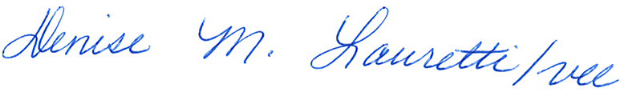

John M. Horn

DML/vll
Enclosure
Cc: John M. Horn and William Morley, Esquire

Order No. 01-17231-010

Staff Counsel: Hanover Insurance Company/Citizens Insurance Company
Not a Partnership

